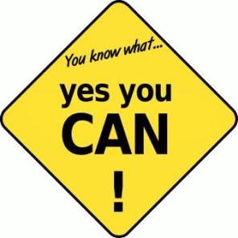
I believe
Writing can help me by ______________________________________________________________________________________________________
I believe
That making mistakes in my writing will __________________________________________________________________________________________________________________
I hope
That in always trying my best to improve my writing in this block, I will __________________________________________________________________________________________________________________
And I know
My biggest strength as a writer right now is __________________________________________________________________________________________________________________
Name:____________________
Writing Goals
During this block, I would like to learn about
__________________________________________________________________________________________________________________
I would like to get better at writing by
__________________________________________________________________________________________________________________
Types of writing I would like to learn are
__________________________________________________________________________________________________________________
How I would like for you to help me as a teacher:
__________________________________________________________________________________________________________________
In peer workshops, I hope to help my classmates by:
__________________________________________________________________________________________________________________
Other goals I have for myself as a writer are
__________________________________________________________________________________________________________________

